Diametrics: A web application that makes looking at data from CGMs in specific time periods easy.

# Abstract

**Background:** Continuous Glucose Monitoring (CGM) systems have revolutionized diabetes management by providing real-time blood glucose tracking. However, the analysis of CGM data for specific periods or linking this data to events (e.g exercise), often requires technical expertise, limiting its accessibility to researchers, clinicians, and patients. Diametrics, a novel web application, was developed to address this gap, offering advanced, user-friendly analysis of CGM data without the need for coding skills.

**Method:** Diametrics was designed using Python 3.9 and Dash, focusing on ease-of-use and versatility. It supports various file formats and a variety of current CGM devices, allowing for multi-format data upload, editable data tables, and customizable analysis options. Usability was tested by XX scientists and clinicians. The application's efficacy was validated using data from three studies involving 418 participants, comparing its performance with iglu, an established tool for CGM analysis, standard metrics of glycemic control. Additionally, its unique period-specific analysis feature was demonstrated through case studies.

**Results:** Users found the site easy to use and analysis for a number of published studies have used the site to analyze their data. Validation results showed that Diametrics accurately replicated iglu’s results for CGM metrics, with Pearson correlation coefficients of 1 for 11 out of 13 metrics. Minor discrepancies in AUC and data sufficiency were noted. Case studies highlighted the application's ability to provide detailed insights into glycemic control during specific events and over extended periods, demonstrating its versatility and accuracy.

**Conclusions:** We have developed a user friendly, accurate, free to use web based tool for analysis of CGM data, Diametrics. This has the added advantages over other available tools in that it can analyze data in specific time periods and by linking data identify glucose changes around events such as meals or exercise. Ongoing development and broader testing are essential to maximize its potential and ensure applicability in diverse scenarios.

# 

# Introduction

Continuous Glucose Monitoring (CGM) has revolutionized the management of diabetes, offering a dynamic way to track blood glucose levels in real-time. This technology is becoming increasingly central to the management of both Type 1 Diabetes (T1D) and Type 2 Diabetes (T2D), where maintaining optimal glucose levels is key to preventing complications. CGM devices provide a wealth of data, enabling patients and healthcare providers to make informed decisions about diet, medication, and lifestyle.

The abundance of data from CGM devices has opened new avenues for researchers to delve beyond the standard metrics of glycemic control. There is a growing need to understand the effects of specific events or interventions on blood glucose levels. However, such detailed analysis often requires technical expertise or coding skills, which can be a barrier for many researchers, clinicians, and patients.

Several no-code web applications are currently available for CGM data analysis, each with varying degrees of complexity and functionality [[1]–[3]](https://www.zotero.org/google-docs/?YuETMv). Whilst they provide basic data analysis and visualization, they often lack the flexibility needed for detailed examination. This limitation can hinder the ability to draw meaningful insights from the data, particularly in understanding the patterns and trends in glycemic responses linked to various lifestyle factors, life events, and physiological states.

In response to these challenges, we created Diametrics: a novel web application designed to bridge the gap in CGM data analysis. We wanted to offer both flexibility and depth in analysis, without the need for coding or advanced technical skills. Crucially, we wanted to provide the ability to analyze specific periods within the CGM data and enable people to look at glucose changes around events that they had recorded e.g exercise or meals. This would allow users to focus on time frames that are most relevant to their needs or research questions.

This study aims to introduce, validate, and demonstrate how Diametrics can be used to analyze different time periods or look at glucose data around recorded events.

# Methods

## Software

Diametrics was developed using Python 3.9, chosen for its robustness and versatility in handling large datasets. The application's architecture is designed using Dash [[4]](https://www.zotero.org/google-docs/?Y4GURX) to be user-friendly, ensuring ease of navigation and interaction for users with varying levels of technical expertise. Diametrics is made available as an open-source tool, available at [www.diametrics.org](http://www.diametrics.org). All code is available in GitHub at <https://github.com/cafoala/diametrics-webapp-dash>. It is also available as a Python package [[5]](https://www.zotero.org/google-docs/?zi5tDk).

## Validation

In our validation process, we utilized data from three distinct studies, totalling 418 participants. The Motivate Study [ref] involved 118 individuals with Type 2 Diabetes (T2D) from the UK and Canada, who were equipped with the FreeStyle Libre CGM system and participated in a prescribed exercise program. We analyzed two weeks of CGM data from this study. Additionally, we included two studies conducted by the JAEB Center for Health Research [[6]](https://www.zotero.org/google-docs/?fo4DGP). The Type 1 Diabetes EXercise Initiative (T1-DEXI) Study [ref], focused on 150 randomly selected individuals with Type 1 Diabetes (T1D) who used the Dexcom G6 CGM system for 28 days. The primary aim of the T1-DEXI study was to investigate the impact of exercise on T1D management. The Type 1 Diabetes EXercise Initiative Pediatric (T1-DEXIP) [ref], paralleled the T1-DEXI study but concentrated on a pediatric population aged 12-18 years with T1D, using the Dexcom G6 for 10 days. This study aimed to explore the effects of exercise in a younger demographic with T1D, and for our validation purposes, 150 participants were randomly selected from this cohort.

The validation process involved comparing the results of 13 different metrics. These were average glucose, standard deviation (SD), coefficient of variation (CV), estimated hbA1c (eA1c), area under the curve (AUC), high and low blood glucose index (HBGI and LBGI), percentage time in normal range (70-180 mg/dL), percentage time below 70 mg/dL, percentage time below 54 mg/dL, percentage time above 180 mg/dL, percentage time above 250 mg/dL, and percentage active wear (data sufficiency). The metrics analyzed for validation purposes included all those included in the American Diabetes Association (ADA)’s International Consensus on the Use of Continuous Glucose Monitoring [[7]](https://www.zotero.org/google-docs/?6RHgyF), with the exception of the number of hypo- and hyper-glycemic events due to ambiguity in the methodology for calculating these specific metrics.

The validation process involved a detailed comparison of the metrics calculated by Diametrics with those obtained from the iglu software. By validating Diametrics with iglu, this also demonstrates concordance between Diametrics and the cgmanalysis (Vigers et al., 2019) and cgmanalyzer (Zhang et al., 2018) packages, because iglu has been validated with them previously (Broll et al., 2021). The Pearson correlation coefficients were used to quantitatively assess the degree of correlation between the two sets of results, thereby providing a robust measure of Diametrics' accuracy and reliability in analyzing CGM data across different studies and devices.

## Case studies

To showcase the capabilities of Diametrics to perform in-depth data analysis into specific time windows, we present two illustrative examples using real CGM data from anonymized participants. The periods of interest in these examples are constructed for demonstration purposes to highlight different functionalities of the software.

To the best of our knowledge, neither example can be readily performed on any other available platform without technical ability and/or significant data processing by the user.

### Example 1: Exploring Glycemic Control During and Around Short Events

This case study is designed to demonstrate Diametrics' ability to analyze CGM data over shorter, specific periods, as well as its functionality in extending the analysis to predefined periods around the primary event. This example effectively illustrates how users can leverage Diametrics to gain insights into glycemic responses to short-term events. This is of particular interest to those trying to understand the broader effects of day-to-day activities such as physical activity or meals, where the glycemic control around the event is also of clinical relevance.

In this example, we use data from two FreeStyle Libre files to examine glycemic control during exercise, the subsequent four hours post-exercise, and the night following the exercise. Rather than using the typical night time boundaries of 12am-6am, we will modify them to 11pm-7am, illustrating Diametrics' flexibility in adapting to different user preferences.

### Example 2: Exploring Glycemic Control for Extended Time Periods

This example serves to show how Diametrics can be used to explore longer-term trends and patterns in CGM data. It highlights the software's utility in segmenting and analyzing data over extended periods, providing valuable insights into how physiological changes over time might influence glycemic control. This feature could be used to explore life events, differing stages of a clinical trial, and different physiological states.

This example employs data from three participants wearing a Dexcom G6, with the analysis focusing on different phases of the menstrual cycle. Additionally, we incorporate a tailored time-in-range threshold of 90-180 mg/dL to showcase the tool's capability for customized settings.

# Results

## Web App Functionality

Diametrics is designed to support the upload of Continuous Glucose Monitoring (CGM) data in various formats, including CSV, Excel, and text files, from multiple devices such as Abbott, Dexcom, and Medtronic. Users have the flexibility to upload multiple files of any size or quantity and can directly edit them within the application, making it suitable for handling extensive datasets.

The application aligns with ADA's International Consensus, offering all of the standard metrics of glycemic control [[7]](https://www.zotero.org/google-docs/?qY8Hvk) (Supplementary Table X). They are displayed in a customizable table, allowing users to focus on relevant data, adjust for day and night times, and switch between mmol/L and mg/dL. Users can download their tailored tables and original combined CGM data for further analysis.

### Flexible analysis options allow users to adjust the metrics to suit their specific needs. This includes the ability to fill gaps in data, adjust day/night time frames, define specific time frames for day and night periods, set custom thresholds for time in range, and provide customizable definitions for glycemic events.

A key feature of Diametrics is its ability to perform periodic analysis, which allows for the analysis of specific periods within the CGM data, such as mealtimes or exercise sessions. Users can upload a file with detailed period information and labels, and the application is capable of analyzing time windows around these events, calculating both standard and user-adjusted metrics for these periods.

For data visualization, Diametrics offers interactive graphs and charts using Plotly [ref], which enhances data interpretation and pattern identification. These visualizations are not only informative but also downloadable and can be manipulated by users. Two example charts are shown in Figure 1, including (a) Ambulatory glucose profile, and (b) percentage time in range for 8 participants.

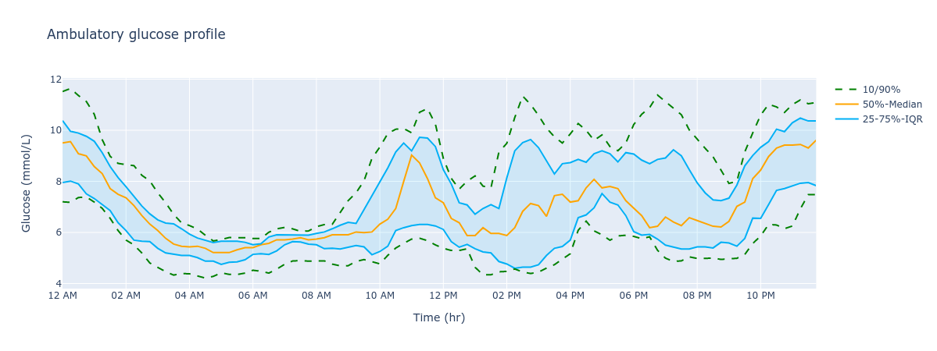

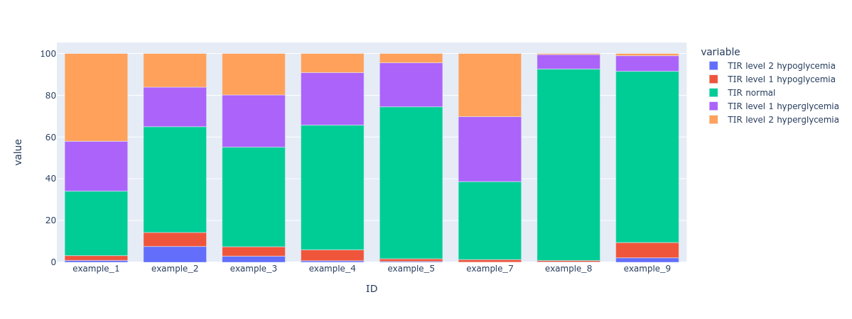

Comprehensive written and video documentation is available within the documentation tab of the web app, detailing each section of the web app, ensuring user accessibility and ease of use.

## Validation

The metrics for the participants in the study were validated. For 11 out of the 13 metrics, Diametrics matched the iglu software results exactly, with Pearson correlation coefficients of 1. The metrics AUC and data sufficiency showed minor discrepancies across the studies. However, these differences were minimal. The correlation remains consistent across all three studies.

Add figure

## Case studies

### Example 1: Glycemic Control During and After Exercise

The worked example is available in Supplementary Video 1.

To begin, we upload the relevant CGM files to the first tab of the Diametric dashboard and check that the files are usable. Next, we will use the Analysis Options tab to adjust the night time period from the standard settings. Instead, we will look at 11pm to 7am (Figure XA). We will proceed to calculate the metrics of glycemic control for the overall data for each participant.

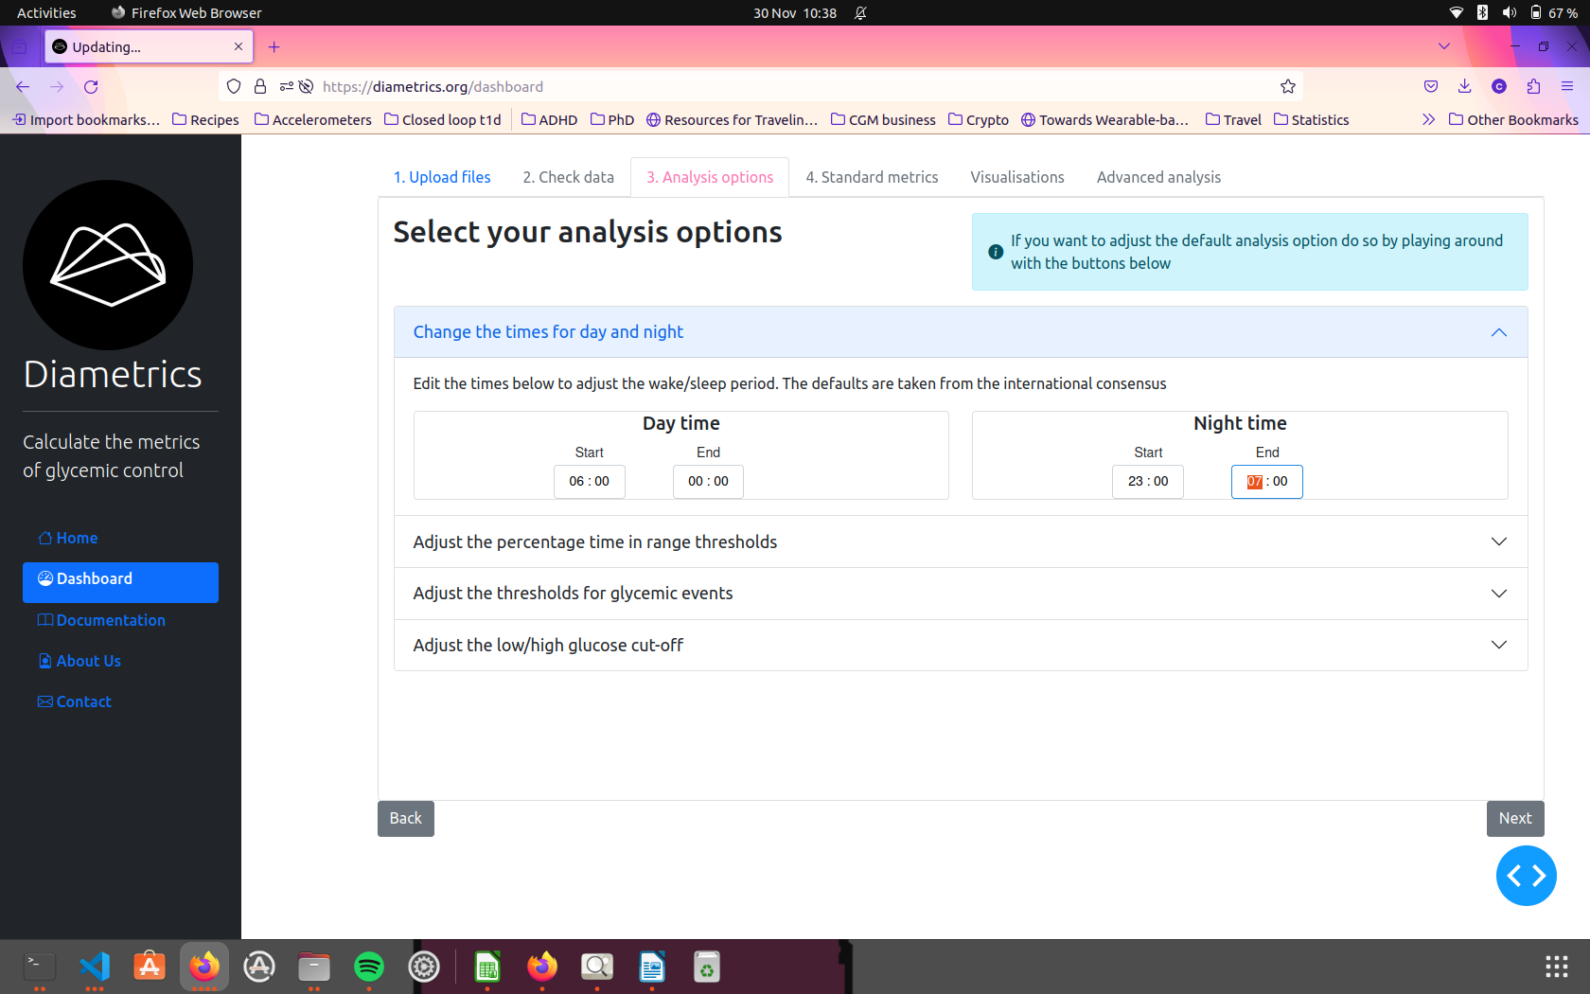

Next, we move to the Advanced Analysis tab to begin the analysis for our periods of interest. For this, we need to upload an external file, either in Excel or CSV format, to specify the periods we want to analyze. This file should include a start date and time for each period, and either an end date and time or the duration. It's important that the file has an ID column, and these IDs must match exactly with those from the files uploaded earlier in the app. These processes are described step by step in documentation pages within the app. Users can also add optional labels to their file to help differentiate between the periods of interest in their own further analysis. In this example, we use a file with the ID, start date-time and duration to give us the period of interest, and two labels - type of exercise and the borg score for intensity (Figure XB).

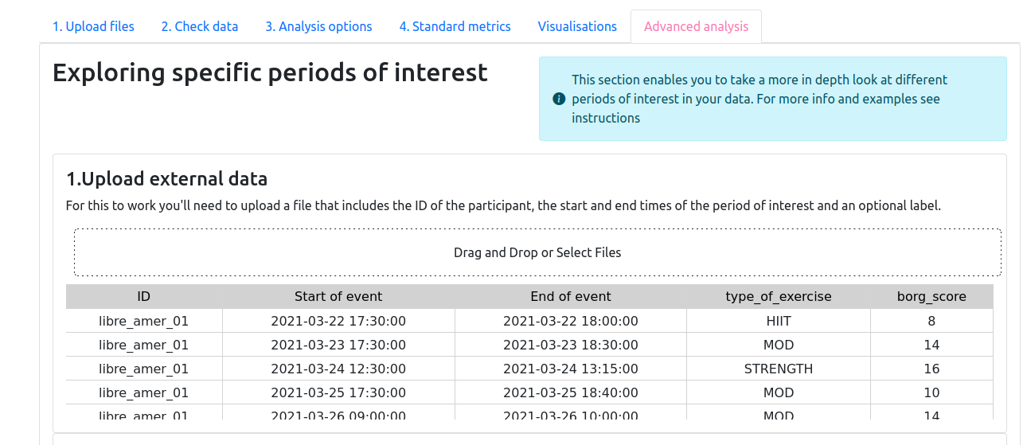

The next section in the Advanced Analysis allows users to look at the windows around the event. The two tick boxes let you choose if you want to see the standard metrics for the whole 24 hours after the period of interest and if you want to see the night after the event. The range sliders below give you the chance to customize the window you are interested in around the periods you’ve entered. For this example, we will use the slider to select four hours after the exercise and check the night after the event box (Figure XC).

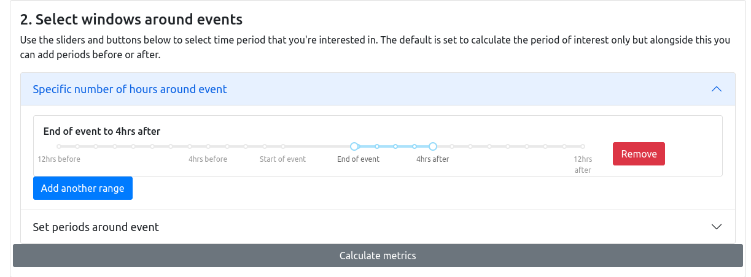

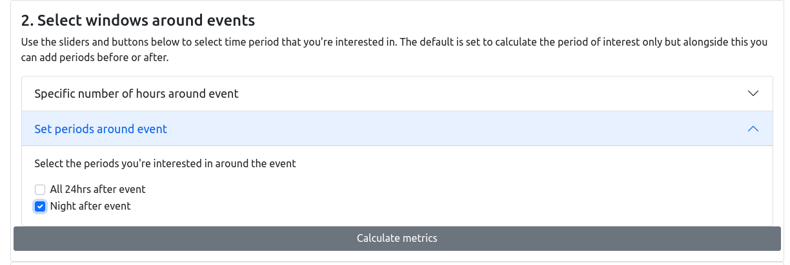

We click the ‘Calculate Metrics’ button which provides us with the results table with all of the available metrics which can be explored in the web app and downloaded for further analysis (Figure XD).

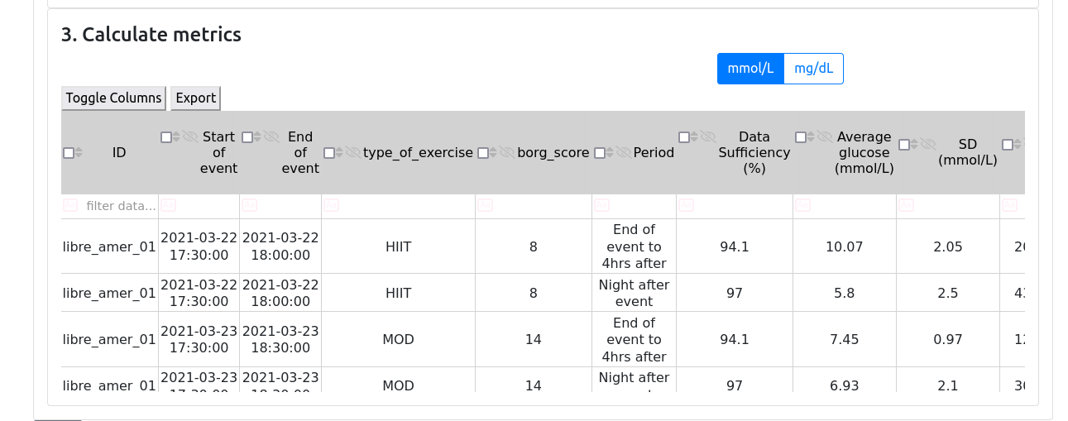

### Example 2: Glycemic Control Across Menstrual Cycle Phases

The worked example is available in Supplementary Video 2.

As before, the CGM files for the participants must be uploaded and checked. Next, in the Analysis Options tab, we add a new threshold from 90-180 mg/dL (5-10 mmol/L) (Figure XA).

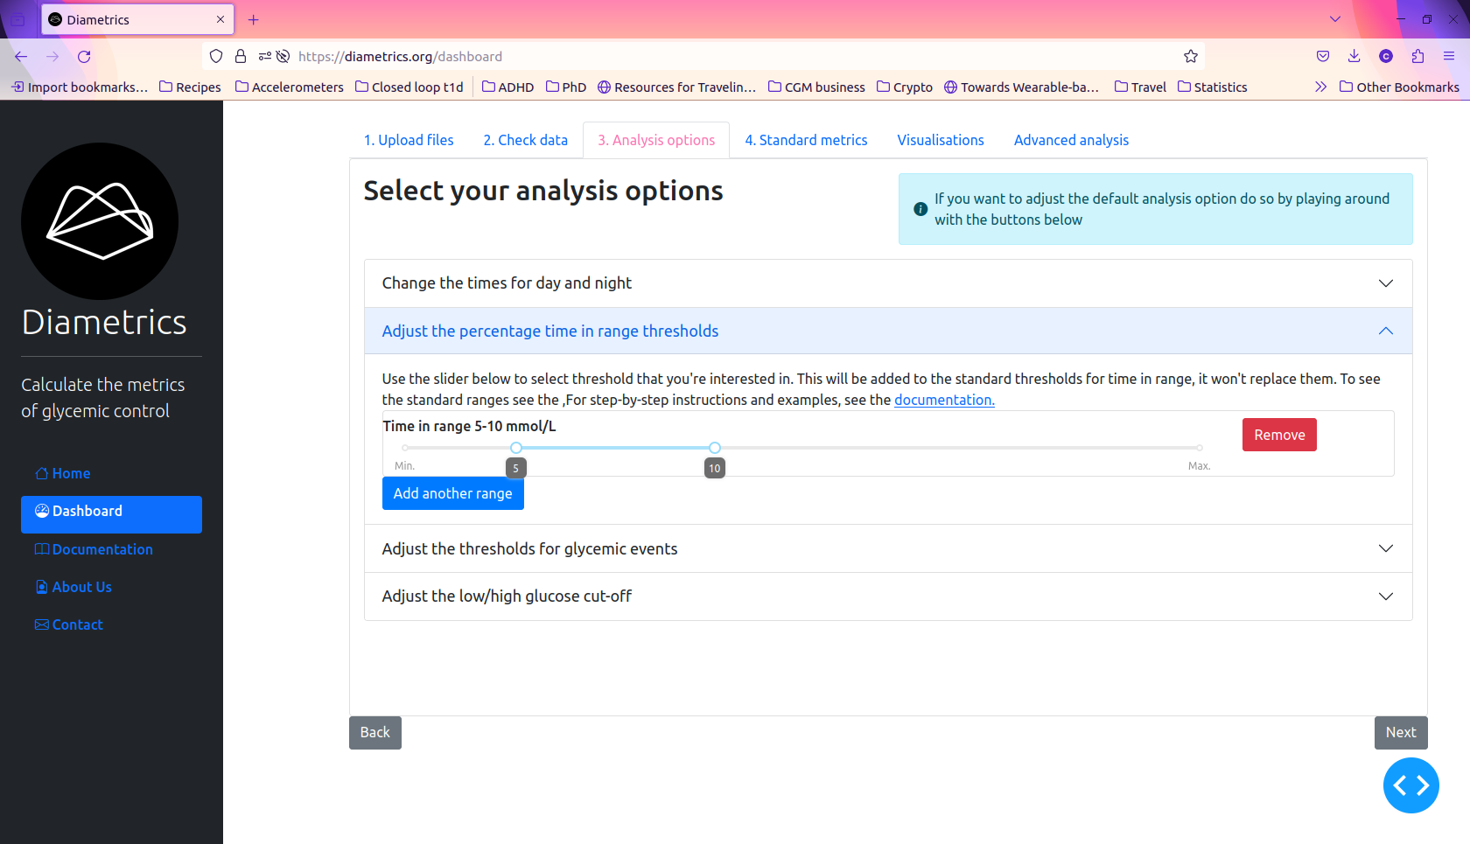

We then calculate the overall metrics and proceed through the Diametrics dashboard to the Advanced Analysis tab. For this example, we have used a file with the ID, start date-time and end date-time to give the periods of interest, and two labels for the ovarian cycle phase and uterine cycle phase (Supplementary Table X).

Since we are not including any windows around the events, we will leave the “Select windows around events” section blank and click the calculate metrics button to provide us with our results table, which includes all the standard metrics and our additional time in range.

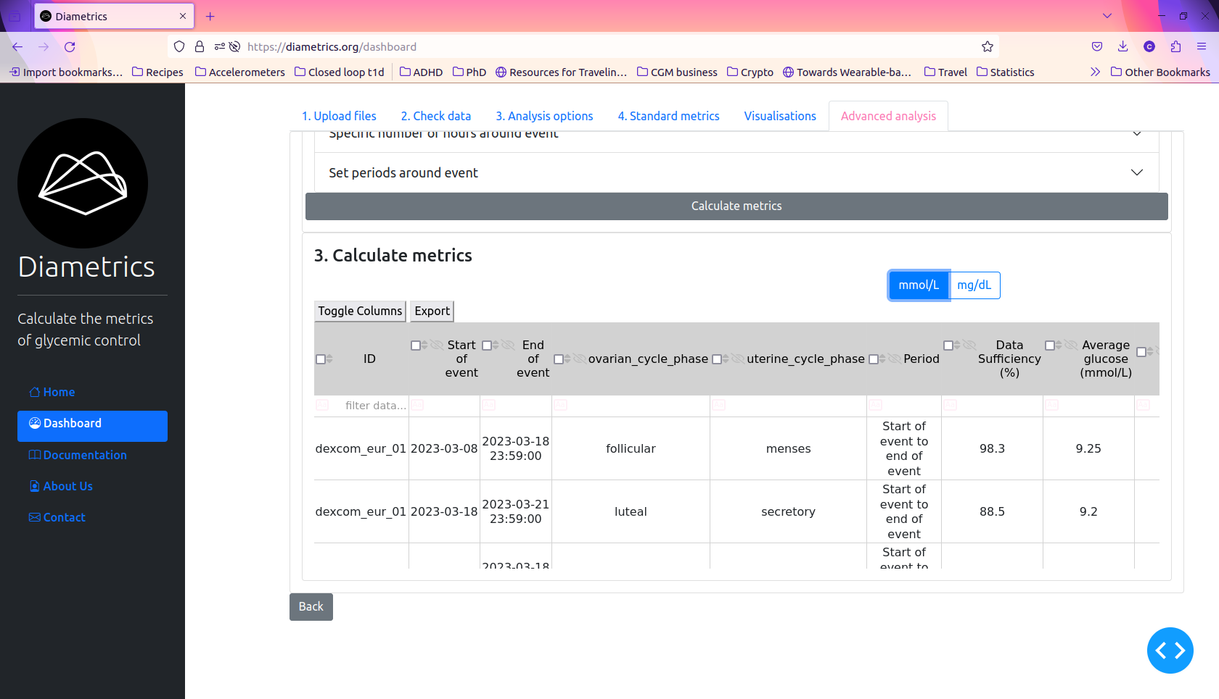

# Discussion

#### Summary

In this study, we introduced, validated, and demonstrated Diametrics, a novel web application designed for advanced analysis of CGM data. Diametrics is a versatile data analysis tool offering multi-format data upload, editable tables, comprehensive metrics calculation, customizable analysis options, period-specific analysis, interactive visualizations, and extensive user documentation. We validated Diametrics against iglu using data from three distinct studies with a total of 418 participants, demonstrating Diametrics’ accuracy in replicating established metrics in CGM data analysis. The application's unique feature of analyzing specific periods within CGM data was showcased through illustrative case studies, highlighting its potential to provide detailed insights into glycemic control during specific events such as exercise and across different phases of the menstrual cycle.

#### Interpretation and implications

Diametrics' user-friendly design significantly lowers the barrier to entry for individuals without extensive technical expertise. This aspect is especially crucial in clinical settings, where healthcare providers can leverage Diametrics for swift and straightforward interpretation of CGM data, bypassing the need for complex data analysis procedures.

The tool's customizable analysis options cater to a wide range of research and clinical needs, allowing for a more nuanced and personalized approach to CGM data interpretation. This adaptability ensures that Diametrics can be effectively used in various diabetes management scenarios, from individual patient care to large-scale research studies.

Our validation process highlighted Diametrics' high accuracy in replicating established CGM metrics, with minor discrepancies in AUC and data sufficiency attributed to differences in calculation methodologies. The consistency of these results across diverse studies, including Motivate, T1-DEXI, and T1-DEXIP, demonstrates the robustness of Diametrics, particularly considering the range of participants and devices involved.

Furthermore, the open-source nature of Diametrics fosters a collaborative environment, encouraging contributions and continuous enhancements from the global community. This approach not only ensures the tool's ongoing relevance but also aligns with the evolving needs and advancements in diabetes research and management.

#### Comparison with Previous Studies

In comparison with existing no-code CGM analysis tools, Diametrics offers several unique advantages. As shown in Table 2, adapted from that used by Chrzanowski et al. [[1]](https://www.zotero.org/google-docs/?rz3rkS), Diametrics provides unparalleled user flexibility, including easy unit switching, adjustable thresholds for time in range, and customizable definitions for glycemic events. Unlike many other tools, it allows for the analysis of multiple periods within the CGM data, a feature particularly beneficial for detailed research studies and personalized diabetes management.

Diametrics also excels in file upload compatibility, supporting a wide range of devices and file formats, thus accommodating a broader user base. Its graphical user interface is designed for ease of use, making it accessible to users without technical backgrounds. The open-source nature of Diametrics, unlike some of the other tools listed, encourages ongoing community-driven enhancements and adaptations.

#### Limitations and Future Directions

While Diametrics shows promise, it's important to acknowledge its limitations. The validation process, though thorough, was limited to specific datasets and may not cover all potential use cases. Future studies could expand the range of data and scenarios tested to ensure broader applicability. Additionally, as with any software tool, there is a need for continuous updates and improvements based on user feedback and technological advancements. Future versions of Diametrics could incorporate more advanced analytics features or integrate machine learning algorithms to predict glucose level trends, enhancing its utility in diabetes management.

#### Potential Impact on Diabetes Research and Management

For researchers, Diametrics is a powerful tool that can deepen the analysis of how various lifestyle factors, such as diet, exercise, and medication regimens, influence blood glucose levels. This enhanced level of detail can lead to more informed conclusions and potentially groundbreaking discoveries in diabetes care and management.

In a clinical context, Diametrics offers a unique advantage for healthcare providers and patients. By enabling more precise interpretation of CGM data, it supports the development of highly individualized diabetes management plans. This tailored approach can lead to more effective management strategies, improving patient outcomes and quality of life.

Moreover, the user-friendly nature of Diametrics lowers the barrier to entry, making it more accessible for a broader range of users. This accessibility could lead to increased engagement with CGM data among patients and healthcare providers. By empowering patients to actively participate in their own data analysis, Diametrics could foster improved self-management practices. For healthcare providers, the ease of use translates to more efficient and effective patient care, as they can quickly analyze and respond to patient data.

# Conclusions

In conclusion, this study introduces Diametrics, a novel, user-friendly web application designed to enhance the analysis of Continuous Glucose Monitoring (CGM) data. Diametrics stands out for its ability to perform advanced, period-specific analysis without requiring users to have coding skills or technical expertise. This feature addresses a critical gap in diabetes management and research, offering a more nuanced understanding of glycemic control in response to specific events or physiological states. By making detailed data analysis more accessible, it has the potential to improve diabetes research and contribute to more personalized and effective diabetes management strategies.

# References

[[1] J. Chrzanowski *et al.*, ‘GlyCulator 3.0: A Fast, Easy-to-Use Analytical Tool for CGM Data Analysis, Aggregation, Center Benchmarking, and Data Sharing’, *Diabetes Care*, vol. 46, no. 1, pp. e3–e5, Jan. 2023, doi: 10.2337/dc22-0534.](https://www.zotero.org/google-docs/?KlJFWl)

[[2] S. Broll *et al.*, ‘Interpreting blood GLUcose data with R package iglu’, *PLOS ONE*, vol. 16, no. 4, p. e0248560, Apr. 2021, doi: 10.1371/journal.pone.0248560.](https://www.zotero.org/google-docs/?KlJFWl)

[[3] E. Olawsky, Y. Zhang, L. E. Eberly, E. S. Helgeson, and L. S. Chow, ‘A New Analysis Tool for Continuous Glucose Monitor Data’, *J. Diabetes Sci. Technol.*, vol. 16, no. 6, pp. 1496–1504, Nov. 2022, doi: 10.1177/19322968211028909.](https://www.zotero.org/google-docs/?KlJFWl)

[[4] S. Hossain, ‘Visualization of Bioinformatics Data with Dash Bio’, 2019.](https://www.zotero.org/google-docs/?KlJFWl)

[[5] C. Russon, ‘Diametrics: an open-source Python package for calculating common metrics of glycemic control’. Aug. 2021. doi: 10.5281/zenodo.1234.](https://www.zotero.org/google-docs/?KlJFWl)

[[6] ‘Improving Exercise with Type 1 Diabetes’, Helmsley Charitable Trust. Accessed: Oct. 12, 2023. [Online]. Available: https://helmsleytrust.org/request_for_proposal/improving-exercise-with-type-1-diabetes-moving-data-towards-solutions/](https://www.zotero.org/google-docs/?KlJFWl)

[[7] T. Danne *et al.*, ‘International Consensus on Use of Continuous Glucose Monitoring’, *Diabetes Care*, vol. 40, no. 12, pp. 1631–1640, Nov. 2017, doi: 10.2337/dc17-1600.](https://www.zotero.org/google-docs/?KlJFWl)

# 

# Tables

|  | **Study** | | |
| --- | --- | --- | --- |
| **Metric** | **Motivate** | **T1-DEXI** | **T1-DEXIP** |
| Average glucose (mg/dL) | 1.000 | 1.000 | 1.000 |
| SD (mg/dL) | 1.000 | 1.000 | 1.000 |
| CV (%) | 1.000 | 1.000 | 1.000 |
| eA1c (%) | 1.000 | 1.000 | 1.000 |
| AUC | 0.999 | 0.998 | 0.996 |
| HBGI | 1.000 | 1.000 | 1.000 |
| LBGI | 1.000 | 1.000 | 1.000 |
| TIR normal (%) | 1.000 | 1.000 | 1.000 |
| TIR hyper | 1.000 | 1.000 | 1.000 |
| TIR level 2 hyperglycemia (%) | 1.000 | 1.000 | 1.000 |
| TIR hypo | 1.000 | 1.000 | 1.000 |
| TIR level 2 hypoglycemia (%) | 1.000 | 1.000 | 1.000 |
| Data Sufficiency (%) | 1.000 | 0.999 | 0.999 |

Table 1. Pearson Correlation Coefficients for Metric Comparison

|  | **Diametrics** | **GlyCulator** | **iglu** | **rGV** |
| --- | --- | --- | --- | --- |
| **Glycemic variability** |  |  |  |  |
| Number of days CGM worn | X | X | X |  |
| Active time % | X | X | X |  |
| Mean glucose | X | X | X | X |
| Glucose management indicator | X | X | X | X |
| Glycemic variability (%CV) | X | X | X | X |
| Time above/in/below range | X | X | X | X |
| Ambulatory glucose profile | X | X | X |  |
| Day and night | X | X | X |  |
| **User flexibility** |  |  |  |  |
| Easy switch between units | X |  |  |  |
| Adjustable thresholds for time in range | X |  |  |  |
| Adjustable thresholds for glycemic events | X |  |  |  |
| Adjustable day/night time | X |  |  |  |
| Multiple periods selection for analysis | X |  |  |  |
| **File upload** |  |  |  |  |
| Medtronic | X | X | X |  |
| Abbott | X | X | X |  |
| Dexcom | X | X | X |  |
| User defined |  | X | X | X |
| **File preparation** |  |  |  |  |
| Period selection for analysis | X | X |  |  |
| Missing data imputation | X | X |  |  |
| Multiple file processing | X | X | X |  |
| Many-to-single file merge | X | X |  |  |
| **Sharing and access** |  |  |  |  |
| Graphical user interface | X | X | X | X |
| Online platform | X | X | X | X |
| Programmatic access | Python | Python | R | R |
| Open source | X |  | X |  |
| Source publication/code repository |  | [10.2337%2Fdc22-0534](https://doi.org/10.2337%2Fdc22-0534) | [10.1371/journal.pone.0248560](https://doi.org/10.1371/journal.pone.0248560) | [10.1177/19322968211028909](https://doi.org/10.1177/19322968211028909) |

Table 2. Comparison of functionality between no-code CGM analysis web applications.